Purpose:
The purpose of this procedure is to provide guidance to the US user community and US TAG to ISO TC176 SC 2 Working Group on Interpretations (TG22) for handling requests for interpretation of the requirements of the ISO 9001 standard.

The elements described in this document cover:
- The communication between the requester and US TG22;
- The communication between TAG 176, US TG22 and ISO/TC 176 SC 2.

TG22 will only accept requests for highly generic interpretations that comply with the guidelines described in this procedure and only as referenced to ISO 9001.

Scope:
The US Working Group on Interpretations (TG22) DOES NOT provide explanations of ISO 9001. Questions concerning the application of the requirements of ISO 9001 are outside the scope of this process and will not be accepted by TG22. Questions concerning terminology are also outside the scope of the interpretations process and will not be accepted by TG22. Specific guidelines are presented below.

TG22 DOES provide clarification of specific ISO 9001 requirements in response to narrowly focused highly generic interpretation questions. This interpretations process is consensual in nature involving the entire membership of US TAG to ISO/TC 176 and, as a result may take some time to produce answers to questions.

Since the US TAG to ISO TC176 (TAG) does not provide explanations of ISO 9001, responses provided under this procedure are opinions and are not to be offered as an official interpretation. Opinions are offered to assist ISO users in their implementation and improvement efforts. These opinions have no formal status and should not be sited in cases of multi-party disputes. For a formal interpretation, users are directed to submit to the International Interpretations process, providing the question meets the requirements for acceptance into that process. (See the current version of ISO document TC176 SC2 N949 SC2 Interpretations Process for further instruction.)

TG22 does not develop or write the ISO 9001 Standard. TG22 only interprets the requirements of the ISO 9001 Standard.

Procedure:
- Members of the ISO 9001 user community in the USA who wish to have an explanation of a specific requirement within ISO 9001 may submit their inquiry in writing to standards@asq.org. The inquiry shall comply with this procedure using the approved form #TC176 SC2 N691 (attached to this procedure).
- The TAG Administrator (Admin) will advise the requester to consult the ISO 9000 series of standards and other published support documents, as well as the listing of ISO/TC 176 SC 2 approved Interpretations (see: www.iso.org/tc176/sc2) before accepting a request. The Admin will also provide a copy of this procedure to requestor with associated forms to be completed. The Admin can also provide a list of current TG22 sanctioned interpretations.
- The request/question shall comply with established criteria. The question should be a request for interpretation, not for information or explanation. It should seek to clarify What is required in the standard and not How the requirement(s) could or should be fulfilled (applied). Therefore, the overall strategic intent is to provide interpretations related to What is required and not How to implement a requirement thereby confirming the original intent of the standard.
- The request for interpretation shall:
  - be formulated in a way that it can be answered with a “Yes” or “No”. If possible, the question should read: “Does clause xyz require that…?”;
  - not be conditional (the use of leading words like when, or, if, etc. should be avoided);
  - be limited to a single issue; multiple issues on the same subject should be submitted as separate requests;
  - make a clear and correct reference to the clause of the ISO 9001 standard;
  - be generic, (i.e. regardless of product, type and size of organization, country or situation);
  - be accompanied, if necessary, by background scenario describing the situation that gave rise to the question in order to make the request clear;
  - NOT involve explanation of terminology or definitions (reference ISO 9000);
  - NOT involve inquiries arising from disagreements between clients and/or consultants representing clients and their registrar/certification body (CB). Organizations in disagreement with a CB are advised to seek resolution through the CB’s formal appeals system. A question arising out of a client-registrar dispute or disagreement may be submitted to the International Interpretations process providing the question meets the requirements for acceptance into that process. (See the current version of ISO document TC176 SC2 N949 SC2 Interpretations Process), and;
  - be communicated in the manner and format specified by this procedure. (Ref: Form TC176 SC2 N691)
- If request meets the criteria above, the Admin logs request, assigns a tracking number and routes request to TG22 expert(s) identified by the TG22 Chair and TAG Administrator. TG experts will respond to the request within fifteen (15) working days. The Admin will track timeliness.
- TG22 expert(s) answer request with “YES” or “NO” and provide justification for opinion. Opinion should reference established Standards or published Guidance Documents citing clauses. To validate the interpretation process, justification based on “tradition” or “past practice” should be avoided wherever possible.
- TG22 opinions can result in several outcomes:
  - When the TG22 expert(s) and Chair opinion(s) agree unanimously, Admin posts response in a secure site and sends Yes/No reply to requestor.
  - In the event the US TG22 expert(s) opinions are not unanimous, to facilitate a consensus opinion, Admin sends outcomes to experts requesting a “majority opinion” and a “minority opinion”. Both opinions are routed to the original list of experts requesting a response based on input from both opinions. TG22 Chair may offer disposition based on telephone or E-mail conversations to facilitate outcome.
  - If consensus is then reached (but not necessarily unanimous(reference footnote)), Admin posts the Yes/No response along with majority and minority opinions in a secure site and sends reply to requestor.
  - In the event consensus is NOT reached (a Yes/No response is not possible), feedback is provided to requestor that the TAG Admin will submit request to the formal international process and keep the requester advised of action taken. Requestor is provided the “TC176 SC2 N949” document (or directions to it) describing the process for international interpretation. Admin posts outcome to database and copies ISO TC176 SC2 Secretariat.
  - Note: In the future, US interpretations may be posted to an online communication tool assessable to the user community or to published media such as Quality Progress.
- The process ends when the reply is sent to the requestor.

Revision History
Status  (Initial/ Revision/ Obsolete) | Document Revision Level | Effective Date | Description of Revision
Initial Issue | 0 | 09/28/2016 | Initial Issue

If changes or improvements are made to this document, it shall be revised, approved and reissued per US TAG policy.

Attachments:
- Process flowchart
- Examples of proper interpretation requests
- Interpretations Request Form N691

− End–

EXAMPLES ON FORMULATING INTERPRETATION REQUESTS

The examples below are shown to clarify types of request that can be presented and the format that can or cannot be responded to by US TG22.

EXAMPLES OF QUESTIONS THAT CAN BE ANSWERED BY US TG22:

Question: Does sub-clause 8.3.2 b) & c) allow the organization to decide on the need, appropriateness and extent of the review, verification and validation to be carried out at each design and development stage?

Question: Does sub-clause 7.5.2 c) require that documents required for the QMS be reviewed as well as approved prior to issue?

EXAMPLES OF QUESTIONS TO BE SENT BACK TO THE REQUESTER WITHOUT INTERPRETATION:

Question: Should the design of the packaging necessary to preserve the conformity of product up to destination be part of the output activities (8.3.5)?

Unacceptable because: It is not possible to provide a generic interpretation in response to this request. It is an implementation question (How to do).

Question: In clause 7.5.3.2 d), we consider that the term “disposition” needs to be clarified. In which context should this term be used?

Unacceptable because: This is a terminology and implementation issue. It is not a question on a requirement of the standard.

Question: My CB gave our company a nonconformance because they said . . .

Unacceptable because: TG22 does not resolve disputes between CB’s and their clients. Use the CB’s dispute resolution process.

Question: Does Clause xxx apply to my company?

Unacceptable because: While the question can be answered with a “Yes” or “No”, applicability (exclusions) depends on multiple criteria that require conditional arguments (if...then) and are therefore not generic in nature. (see above Clause 4.5)

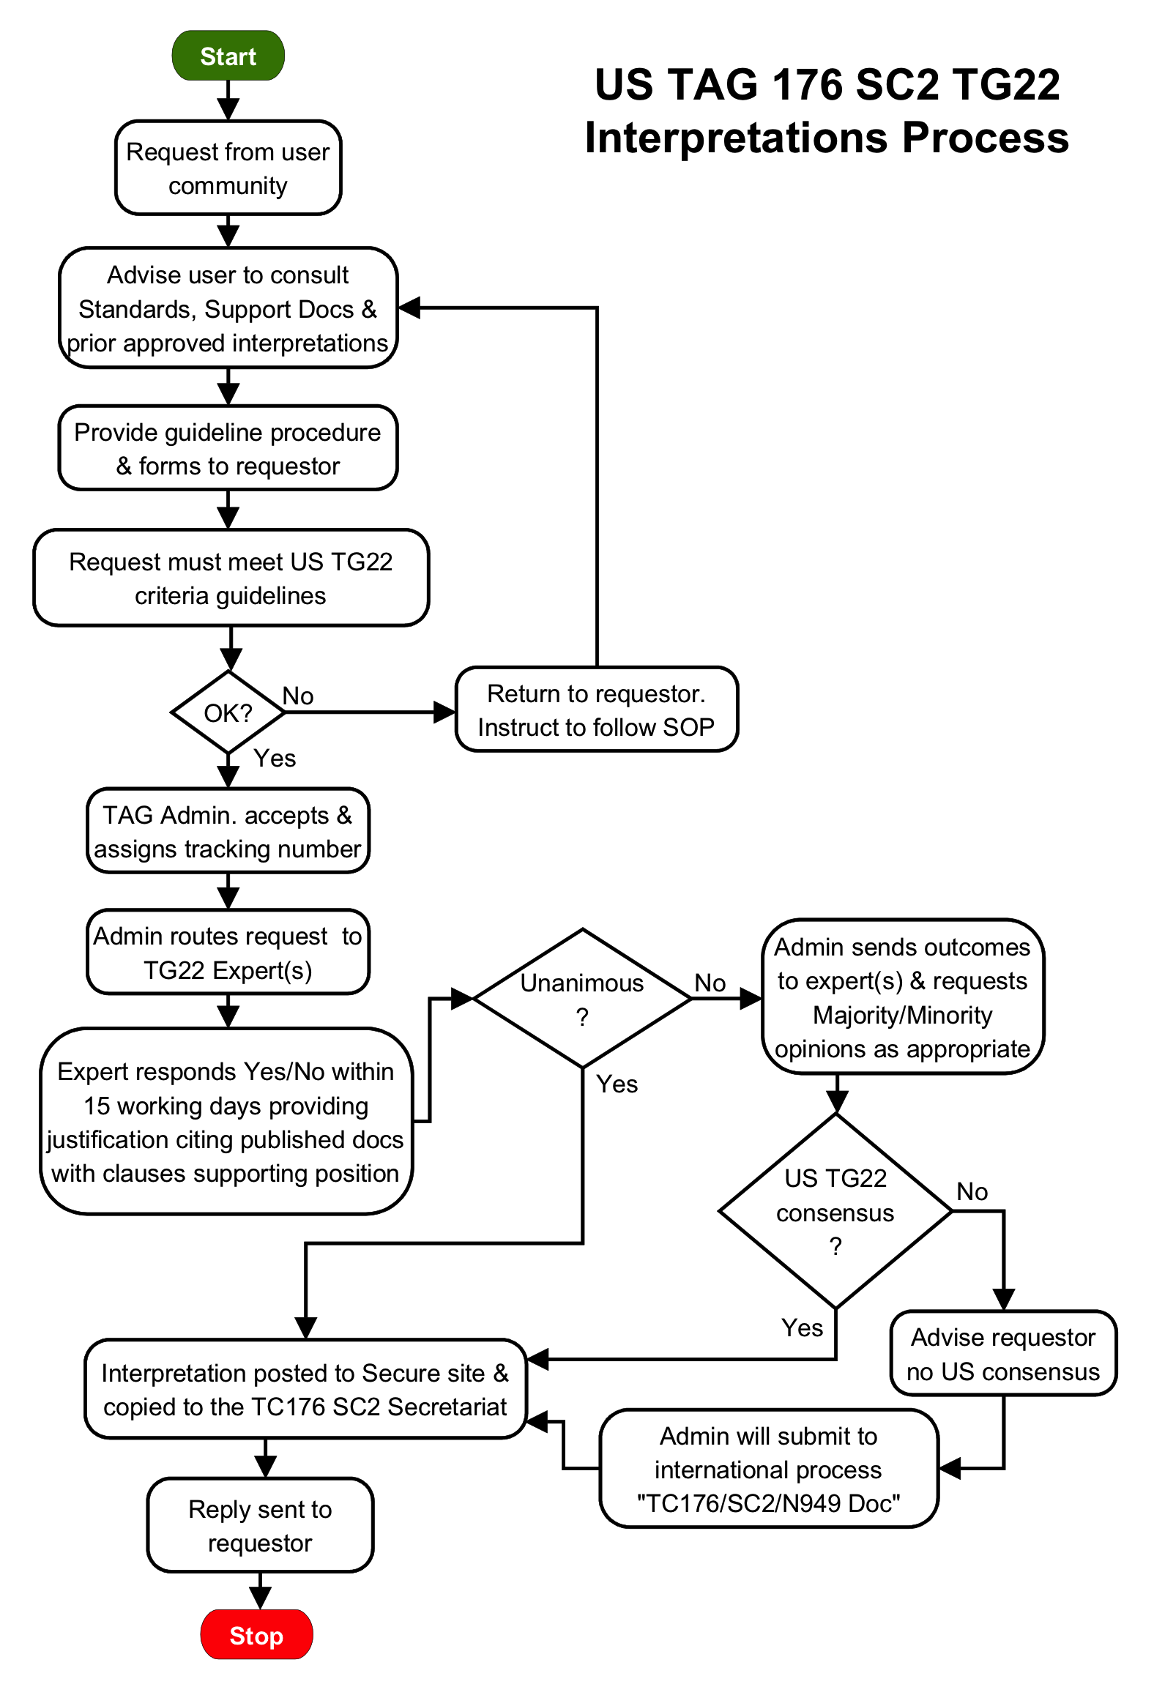
ISO/TC MB/L Org: |  |  |  | P |  | X |  | O |  |  |  |  | L |  |  |  |  |  |  |  | ORIGINAL REQUESTER:
M Body/L Org: |  |  | ANSI |  |  |  |  |  |  |  |  |  |  |  | Organization: |  |  |  |  |  |  |  |  |  |  |  |  |  |  |  |  |  |  |  |  | Date:
Contact person: |  |  |  |  |  |  |  |  |  |  |  |  |  |  | Contact person:
Address: |  |  |  |  |  |  |  |  |  |  |  |  |  |  | Address:
Phone: |  |  |  |  | Fax: |  |  |  |  |  |  |  |  |  |  |  |  |  |  |  | Phone: |  |  |  |  |  |  |  |  | Fax:
e-mail: |  |  |  |  |  |  |  |  |  |  |  |  |  |  |  |  |  |  |  |  | e-mail:
REQUESTING ORGANIZATION DETAILS:
Main Activity:
No. of employees: |  |  |  | 1 to 14 |  |  |  |  | 15 to 49 |  |  |  |  |  |  |  |  |  | 50 to 249 |  |  |  |  |  |  | 250-500 |  |  |  |  | 500+
ISO 9001 registered: |  |  |  |  |  |  |  |  |  |  |  | Yes |  |  |  |  |  |  |  | No |  |  |  |  |  | Implementing
Interpretation Request: |  |  |  |  |  |  |  |  |  |  |  |  |  |  |  |  |  |  | ISO 9001 version: |  |  |  |  |  |  |  |  | 2008 |  |  |  |  |  |  |  |  | 2015
 |  |  |  |  |  |  |  |  |  |  |  |  |  |  |  |  |  |  | ISO 9001 Clause:
(Note: Formulate question in format to enable YES/NO answer):
If necessary, please describe background scenario that gave rise to the question:
Answer:

Consensus Opinion is defined as "General agreement, characterized by the absence of sustained opposition to substantial issues by any important part of the concerned interests and by a process that involves seeking to take into account the views of all parties concerned and to reconcile any conflicting arguments. • NOTE Consensus need not imply unanimity." (Source: ISO Directives)

